**1.- Combinación de cabeceras múltiples y columnas expandidas**

|  |  |  |  |
| --- | --- | --- | --- |
| **Head1** | | **Head2** | |
| **Head 3** | **Head 4** | **Head 5** | **Head 6** |
| A | B | C | D |
| E | F | G | H |

2.- **Cabeceras laterales**

|  |  |  |  |
| --- | --- | --- | --- |
| **Head1** | Item 1 | Item 2 | Item 3 |
| **Head2** | Item 4 | Item 5 | Item 6 |
| **Head3** | Item 7 | Item 8 | Item 9 |

3.- **Combinación de cabeceras superiores y laterales. Tabla centrada. Contenidos centrados. Título al pie.**

|  |  |  |  |  |  |
| --- | --- | --- | --- | --- | --- |
|  | **TABLE** | **TR** | **TD** | **TH** | **CAPTION** |
| **BORDER** | X | - | - | - | - |
| **ROWSPAN** | - | - | X | X | - |
| **COLSPAN** | - | - | X | X | - |
| **ALIGN** | - | X | X | X | X |
| **VALIGN** | - | - | X | - | - |
| **WIDTH** | X | - | X | - | - |
| **HEIGTH** | X | - | X | - | - |
| **CELLPADDING** | X | - | - | - | - |
| **CELLSPACING** | X | - | - | - | - |
| Resumen de tablas | | | | | |

4.- **Ejemplo con todos los elementos y parámetros**

|  |  |  |  |
| --- | --- | --- | --- |
|  |  | **Media** | |
|  | **Altura** | **Peso** |
| **Sexo** | **Hombres** | 1.9 | 85 |
| **Mujeres** | 1.7 | 60 |

<TABLE BORDER>

<TR> <TD><TH ROWSPAN=2></TH>

<TH COLSPAN=2>Media</TH></TD>

</TR>

5.- **Tabla sin bordes**

|  |  |  |
| --- | --- | --- |
| Item 1 | Item 2 | Item 3 |
| Item 4 | Item 5 |

6.- **Tabla con borde de 10 puntos**

|  |  |
| --- | --- |
| Item 1 | Item 2 |
| Item 3 | Item 4 |

7.- **Anidando tablas. La tabla ABCD dentro de la tabla 12345**

|  |  |  |  |  |  |  |
| --- | --- | --- | --- | --- | --- | --- |
| 1 | 2 | 3   |  |  | | --- | --- | | A | B | | C | D | |
| 4 | 5 | 6 |

8.- **Una tabla de cuatro celdas. Cada una de un color.** (Sólo Netscape 3.0 o superior)

|  |  |
| --- | --- |
| Texto ROJO | Texto VERDE |
| Texto AZUL | Texto AMARILLO |

9.- 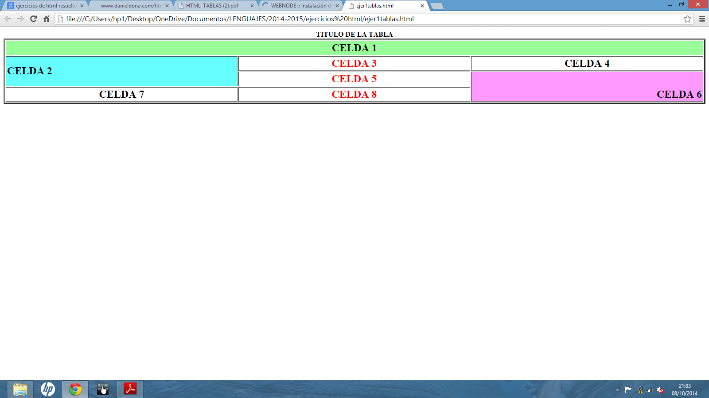

10. Construye el parchis

